Dribbling and ball manipulation -fun warm up
Alex Campbell

Scene 1
6 - 10 players with footballs in an area suitable for age and ability. Within the area and on the outside of the area position a random number of cones. Players should be encouraged to dribble with their heads up, use their little and big toes to dribble, to change direction and pace, to use their imagination, to experiment and have fun and to use the other players and cones as passive opponents to beat.
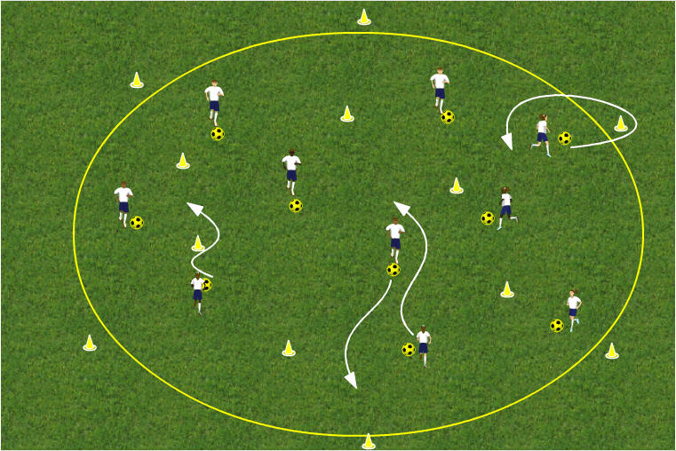

Scene 2
Encourage the players to use different dribbling tricks , such as the Mathews, the Giggs, The Beardsley and turns to change direction such as the drag back, the Cruyff, the big and little toe hook

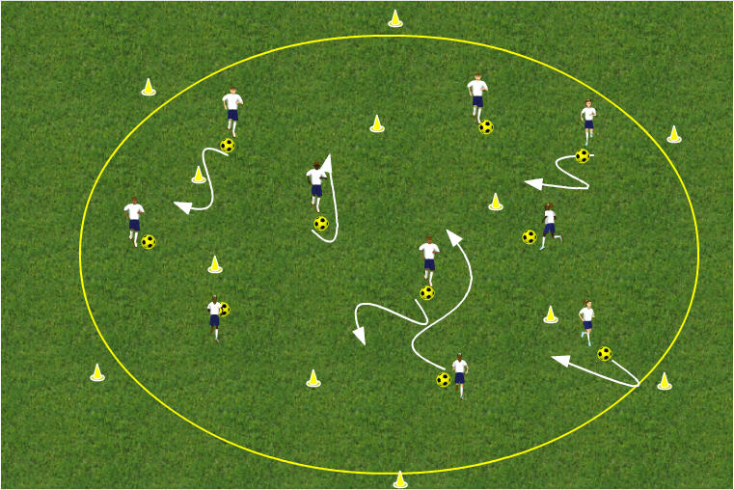
Coaching points
- Players to keep their heads up
- Keep the ball moving
- Keep it under control and close
- Manipulate the ball using different parts of the foot
- Use tricks
- Use changes of pace and direction

