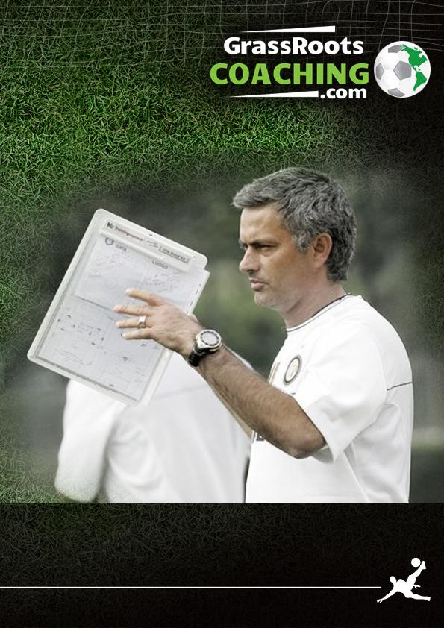
FOOTBALL ASSOCIATION LEVEL 2 COACHING
Improve the Technique of Close Range Finishing
FOOTBALL ASSOCIATION LEVEL 2
Improve the Technique of Close Range Finishing

INTRODUCTION

Mike Trusson, who is a very experienced Football Association Level 2 Tutor and has tutored on over 50 Level 2 Courses, has written the content for the Technique of Close Range Finishing.

Mike is also the owner of www.grassrootscoaching.com which has over 300 animated, interactive 3D coaching sessions and a comprehensive section on the FA level 2 practical coaching curriculum with videos and downloadable PDF’s.

The graphical content has been designed using Coaches Chalkboard, which is a very simple to use online football training planning software tool, which is available FREE at www.grassrootscoaching.com/freefootballcoaching/

WHAT IS A TECHNIQUE

A technique is a basic building block of football. For example the technique of Close Range Finishing is the ability of players to finish from close range in a variety of game realistic situations. These close range finishes need to be realistic to a game and should replicate a variety of situations players might find themselves in a game, be it a composed side foot finish, a first time shot, a turn and shot or combination play between strikers.

The more opportunities the player has to practice these techniques in a game related practice, then the better the player will be at mastering these basic techniques of the game, which will improve the players confidence and the more chance they will have of improving as a player.

A technical session is unopposed so that the players can practice these techniques without the pressure of a defender or opposition player, which allows them time to focus and have time on mastering the technique.

But, players also need to be appropriately challenged in the practice. So in this practice there is a challenge competition to see which team can score the most goals in an allotted time. Players love the competitive element of the challenges. But that competitive factor of the challenge will also make players hurry their finish and make wrong choices as they strive to compete. As a result the quality of the finishing will decrease as players lose composure and rush to make to shoot as quickly as they can.

This allows the coach to help the players make decisions about using the correct finishing technique, composure in front of goal and decisions on finishing first time, setting up a team mate or controlling the ball and then shooting.

PROGRESSIONS

Look out for the progressions to The Technique of Close Range Finishing – The Skill of Close Range Finishing and Small Sided Games to improve Close Range Finishing.

In addition there are E Books available covering the Technique, Skill and Small sided games for all the FA Level 2 Practical Curriculum.

- ORGANISATION.  - Suggested area size. 30 - 35 yards long x 15 - 20 yards wide.  - Position a full size goal in the middle of the pitch with a GK. The GK keeps goal from both sides  - There are two strikers in each of the areas –either side of the goal, they are the close range finishers  - There are two mobile servers at each end of the pitch, there job is the field the ball and pass into the strikers to finish inside the penalty areas  - There is a spare GK, with footballs on the side of the pitch by the goal. If a ball goes out of play they restart the practice by throwing the ball to the servers at either end. They also rotate with the GK in goal  - If the GK saves the ball, they throw to the servers at the opposite end from the shot  - If a shot goes past the goal, it goes through to the opposite servers who pass into the strikers to look to score  - Play rotates end to end with lots of shots | 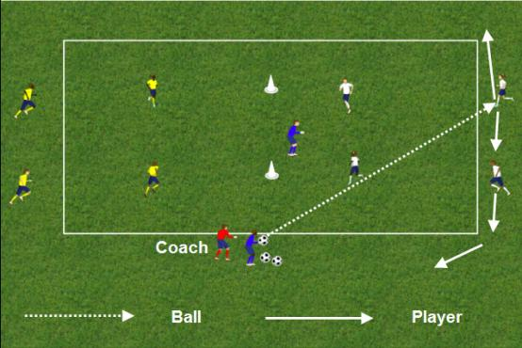  EQUIPMENT  - Supply of footballs, cones to mark out areas, poles or large cones for goals, bibs.  PURPOSE  - To improve the technique of Close Range Finishing  START  - Ball is served from the spare GK to the servers at one end of the field. The servers are like midfield players on the edge of the penalty area in a game and should move to “field” any ball that comes in their direction
- MOVEMENT FROM STRIKERS TO CREATE AND FIND SPACE  - As the ball reaches the servers, the two strikers must look to move, like strikers would in a crowded penalty area, to find space to receive the ball  - The strikers should communicate with the servers when and where they want the pass  - The first thing the coach needs to create is a positive and realistic attitude to finishing.  - Can a striker receive a pass, get the ball out of their feet, get their head up and see the goal and GK and set themselves for a shot | 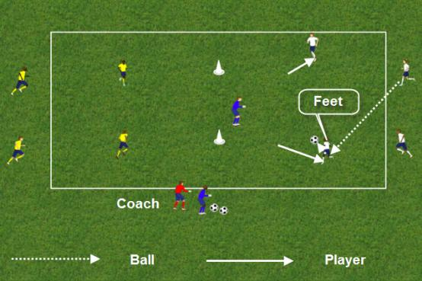

- ACCURATE, COMPOSED TECHNICAL FINISH, REBOUNDS  - If possible, the finishing player should get their head up before shooting, so they can assess the GK’s position, see where the goal is and the distance and angle of shot  - This will help them decide on the most appropriate technique to use to shoot.  - The shot should be accurate, composed and on target  - The second striker should time their run to follow up for rebounds and to make the goal bigger for off target shots  - CONDITION FOR EVERY SHOT: As the ball goes past the goal, the strikers on the other side of the goal leave the ball to go through to the servers. The servers will need to move quickly to field the ball and serve the ball back into the strikers who react to find space in the area.  - Servers can pass to each other and strikers react and move to the pass between servers | 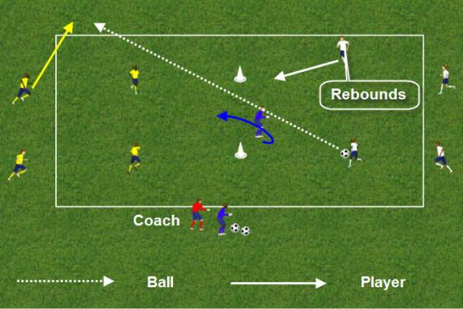  - CONDITION FOR EVERY SHOT: After the shot, the GK spins and now looks to save on the other side of the goal. If the GK saves the ball, they throw the ball to the servers on the opposite side from where the shot came from  - CONDITION FOR EVERY SHOT: If the ball goes out of play, the spare GK throws the ball to the servers on the opposite side from where the shot came from
- CLEVER TIMED STRIKERS MOVEMENT TO CREATE SPACE IN THE AREA  - As the ball goes to one of the servers, the strikers should react with clever, timed movement to create space in the penalty area to receive a pass | 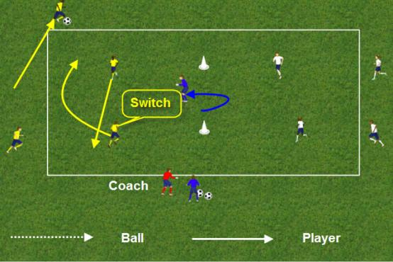

- MOVEMENT FOR A THROUGH PASS  - This clever, timed movement might create a through pass opportunity, where the striker runs onto the ball  - Encourage the striker to be composed, look up and use a realistic, appropriate, accurate and effective finishing technique  - It might be that the striker strikes the ball early to catch the GK flat footed; Or takes the ball closer to the GK before finishing or taking the GK on 1 v 1  - Watch out for the second striker following up for rebounds | 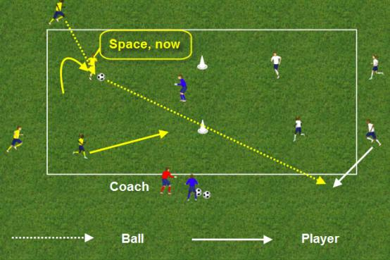
- TURNING AND FINISHING  - There will be situations where the receiving striker might look to turn quickly and finish  - Encourage the striker to use an appropriate quick turning technique and an accurate, composed finishing technique.  - Rebounds! | 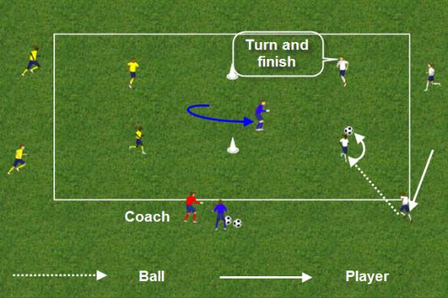

- THE IMPORTANCE OF FOLLOWING UP FOR REBOUNDS  - It is no co – incidence or luck that the best goal scorers get more than their fair share of tap ins and rebound finishes  - It is therefore important that the striker not shooting follows up for rebounds on every shot  - Technically, the striker following up for rebounds should time their run, so as not to be offside and should make sure they not only are first to any rebounds, but also are in a position to make the goal bigger for the shooter by covering the area outside of the post closest to them and therefore making the goal bigger | 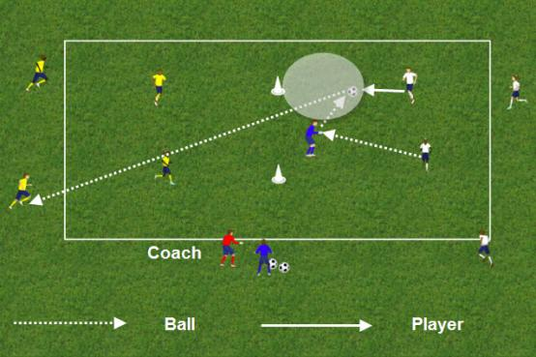
- STRIKERS COMBINING QUICKLY  - Encourage the strikers to look for quick, clever combination set up play in the area  - In this example, the striker closest to the ball, spins and times their run for a set up shot opportunity  - The striker receiving the ball doesn’t have to set the supporting striker up, it will be their decision, but it will provide another, different and realistic game scenario shooting situation | 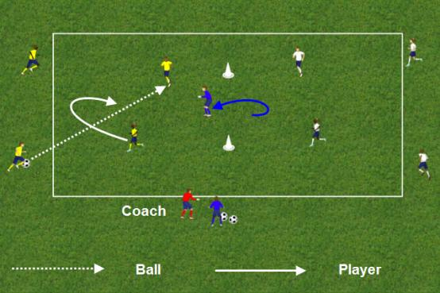

- ANGLE OF SUPPORT – QUICK PLAY  - With quick passing, good communication and timed support play, strikers can create close range finishing opportunities  - The strikers will need to make decisions about playing first time quickly and whether to control and finish or finish first time  - But whatever their decision, it must be realistic to a game, quick and positive  - Encourage players to think about the timing and angle of their support movement. Can they ideally be facing the goal as they strike the ball? | 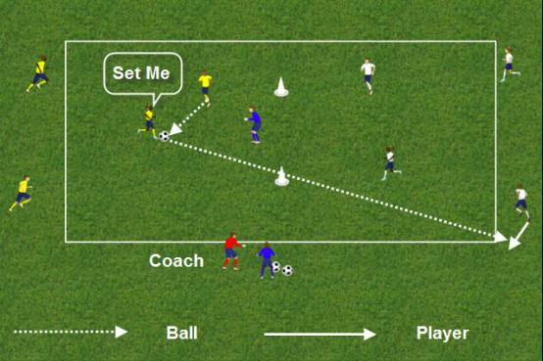
- PULLING THE BALL BACK OR SHOOTING FROM ACUTE ANGLES  - In this situation, one of the strikers has received a pass from a server in a wide area  - The decision is shoot across goal or from this position pass to a player or pass into space for the second striker to attack the ball;  - If not a shot, can they cross the ball or pull the ball back for the supporting striker  - The supporting striker has initially positioned themselves for a shot across goal, a cross or a pull back  - If the striker with the ball looks up and the strikers communicate, then it will help their decision on the best option | 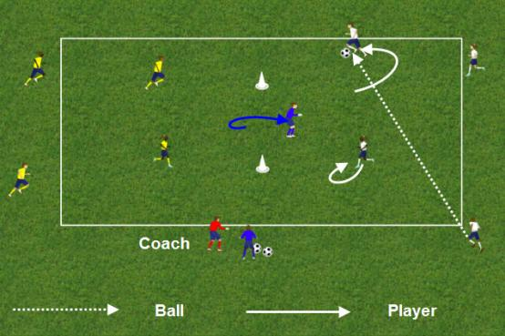

- FINISH FROM A PULL BACK  - The supporting striker has checked away from the goal and communicated where they want the pass  - The pass will have pace on it and technically the striker can use this pace on the ball to guide the ball towards the goal with a first time shot  - It is important that the shooter adjusts their feet to get in the line of the pass; They concentrate and keep their head and body over the ball to keep the shot down and use the pace of the pass to deflect the ball accurately towards the goal | 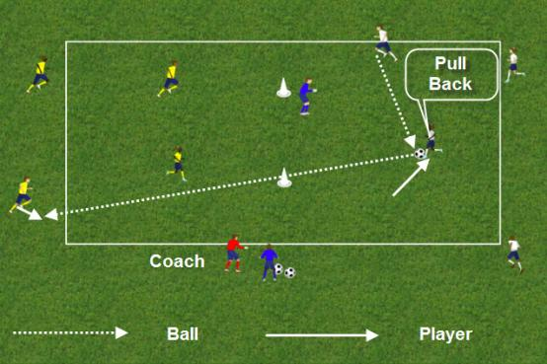
- SHOOTING ACROSS GOAL  - Encourage strikers to shoot low across the goal from wider positions  - The advantages of shooting across goal are; The possibility of rebounds from the GK; There is a bigger area of the goal to hit with the shot; If the shot misses the goal at the far post, team mates if they follow the shot up to the far post area might have a tap in  - Technically, the striker will look to use their laces to strike the ball to generate more power; They should look to strike through the middle and centre of the ball, keeping their body over the ball, concentrating on keeping the ball low and accurate, rather than trying for outright power  - It is important that the second striker times their run into the far post area, so that if the GK spills the ball, they might get the rebound and if the striker misses the far post with the shot, they might have a tap in | 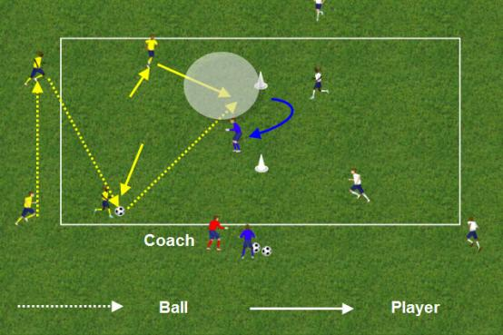

- ATTACKING CROSSES  - Encourage the servers to also take the ball into wider areas, creating crossing situations  - As the ball is with the server in the wider areas, the strikers should pull away from the ball, to leave space to attack the cross  - The strikers should look to make timed runs to attack the near and far post areas  - Strikers will need to communicate with each other to sort out who makes which run – near post, far post | 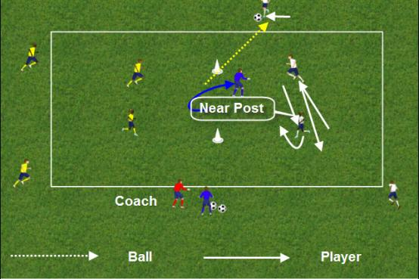
- FINISH FROM CROSSES  - The strikers should make sure they time their runs to attack space and try and be inside the line of the goal posts as the ball is passed into the space in front of goal  - They will need to angle their runs so that they can get in the line of the cross  - Because the cross will have pace on it, the strikers need to concentrate on making a solid contact with the ball, keeping their head and body of the ball, so they use the pace of the cross to deflect the cross towards the goal | 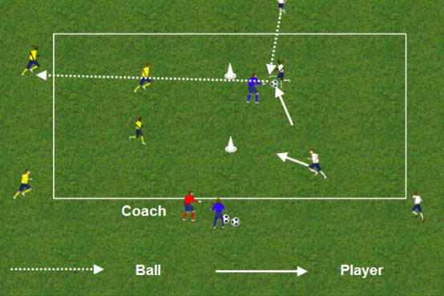

- ROTATE PLAYERS  - To encourage more movement from the players and to ensure all the players have the opportunity of close range finishing opportunities, then after every shot the servers and strikers rotate positions  - Rotate GK’s often  - CHALLENGES  - To make the practice more realistic and challenging, set the players a competitive shooting challenge  - In 2 or 3 minute periods, which team can score the most goals  - Players must rotate after every shot  - Teams get an extra goal for a first time finish: For a turn and finish: For a quick, first time 1 – 2: For a finish from a cross  - The challenge must be game paced and realistic, so if players score in an unrealistic way, the coach disallows the goal | 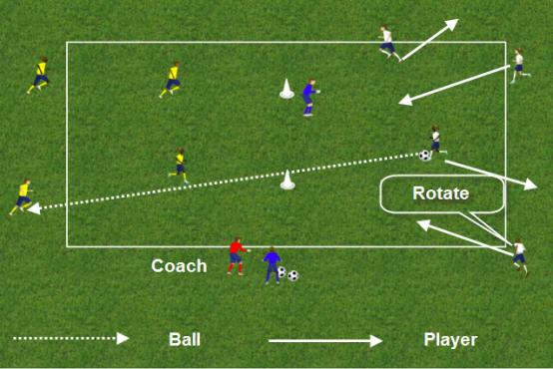  - If ball goes out of play, spare GK serves the ball to the team that didn’t have the shot  - If GK saves the ball they serve the ball to the team that didn’t have the shot
- FINISH FROM CROSSES
- The strikers should make sure they time their runs to attack space
- They will need to angle their runs so that they can get in the line of the cross
- Because the cross will have pace on it, the strikers need to concentrate on making a solid contact with the ball, keeping their head and body of the ball, so they use the pace of the cross to deflect the cross towards the goal

- KEY COACHING  - Strikers’ movement to find space and receive the ball in the area  - Positive attitude and decision – can the receiving player shoot quickly and accurately  - Ball in front and out of feet, to enable the head to be up and assess the GK’s position and distance / angle to goal  - Decision of first time shot or control and shoot.  - What are the factors that will influence this decision? Pace of the ball, height of the ball, body position – facing goal or away from goal? How much time there is?  - Decision of technique of shot to use – side foot, power shot, volley.  - Application of the correct finishing technique – Part of foot? Area of ball to strike? Body position?  - Clever play, turning and shooting, dribble and shoot  - Hit the target – accuracy over power when close to goal. Be calm and composed  - Timing of movement to follow up for rebounds and make the goal big for angled shots  - Finishing from crosses – timed movement to leave and attack space.  - Finishing from crosses - use the pace of the ball to deflect the ball into the goal  - Clever, quick, combination play and communication between strikers to create realistic finishing opportunities  - Support player – angle and distance of support to try and face the goal when receiving the pass to make the shot easier | 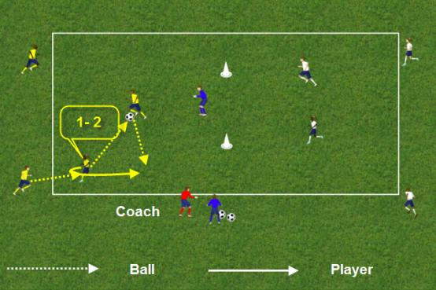  - PROGRESSIONS  - Progress to the skill of close range finishing

On the next 4 pages there is an FA level 2 Coaching Session Planner Template. Please feel free to print it out and use. You will need to complete the details relevant to your session and needs.

Coaching Session Planner (Suggested)

Candidate Coach |  | Date Produced
Coach Educator |  | Time Available

Information on Players
No. of Player |  | Age |  | Ability Level

Medical Info.

Particular Needs

Information on Facilities and Resources
Location | . | Session Date

Facility Needs | Goals, safe and suitable playing area. Toilets
Equipment Needs | Balls, bibs, cones, Poles for goals
Health & Safety | Check Players for injury and for personal health and safety. Suitable footwear, clothing, shin pads, jewellery, Complete pitch check and ensure first aid kit and mobile telephone are on site.  Risk assessment carried out prior to session start.
Action Plan, Points from previous  Sessions: | Give good demonstrations and intervene as appropriate. Ask questions of players. Use Guide and Discovery style of coaching with players. Progress the practice to the players needs
Session Plan
Session Aim | To improve the technique of close range finishing

Timings

Warm Up Activities | Gradual increase of warm up activities with the ball. Looking to increase the pace and intensity of the players movement to game intensity prior to the session. Looking to increase heart rate and blood flow. Also looking to tune the players in mentally to the upcoming session. Stretching of the main football muscle groups | 10 minutes
Cool Down Activities | Gradual decrease of physical activity – run to jog to walk. Gentle stretching of the main muscle groups. Gravity led exercises to rid the body of lactic acid. | 10 minutes

Session Plan
Session Title | Improve the Technique of Close Range Finishing | Timings
Key Technical Aspects/ Factors | - Strikers’ movement to find space and receive the ball in the area  - Positive attitude and decision – can the receiving player shoot quickly and accurately  - Head to and assess the GK’s position and distance / angle to goal  - Decision of first time shot or control and shoot.  - Decision of technique of shot to use – side foot, power shot, volley.  - Application of the correct finishing technique – Part of foot? Area of ball to strike? Body position?  - Clever play, turning and shooting, dribble and shoot  - Hit the target – accuracy over power when close to goal. Be calm and composed  - Timing of movement to follow up for rebounds and make the goal big for angled shots  - Finishing from crosses – timed movement to leave and attack space.  - Finishing from crosses - use the pace of the ball to deflect the ball into the goal  - Clever, quick, combination play and communication between strikers to create realistic finishing opportunities  - Support player – angle and distance of support to try and face the goal when receiving the pass to make the shot easier
Session Content | 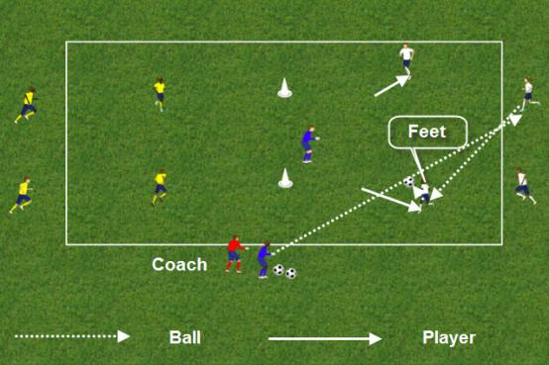  ORGANISATION  - Suggested area size. 30 - 35 yards long x 15 - 20 yards wide.  - Position a full size goal in the middle of the pitch with a GK. The GK keeps goal from both sides  - There are two strikers in each of the areas –either side of the goal, they are the close range finishers  - There are two mobile servers at each end of the pitch, there job is the field the ball and pass into the strikers to finish inside the penalty areas  - There is a spare GK, with footballs on the side of the pitch by the goal. If a ball goes out of play they restart the practice by throwing the ball to the servers at either end. They also rotate with the GK in goal  - If the GK saves the ball, they throw to the servers at the opposite end from the shot  - If a shot goes past the goal, it goes through to the opposite servers who pass into the strikers to look to score  - Play rotates end to end with lots of shots | 25 -30 minutes.

LTPD 4-Corner Model Outcome

When planning your session you will need to consider what outcomes you are trying to achieve in relation to the 4-corner model. You should aspire to identify outcomes for all 4-corners for each of your sessions.

Technical  - Shooting  - Passing  - Receiving  - Ball control  - First time passing  - Decisions  - Support Play  - Combination play  - Rebounds | Psychological  - Imagination  - Decision making  - Confidence  - Self Belief  - Realism
Physical  - Running  - Turning  - Balance  - Agility  - Changes of pace and direction | Social  - Decision making  - Fair play  - Communication  - Team work  - Challenges / competition

Development of the Session
Some players are struggling to cope with the session, how would you adapt it to make it more achievable for them. | Make the area bigger to give the players more space and time.  Slow down the practice to walking pace, and then increase the pace, as the players get better. Spend more time on the technique with the players.
Some players are finding the session to easy, how would you adapt it to make it more demanding for them. | Rotate players quicker  Introduce the challenges sooner  Progress to a skill
Identify what sessions you would ideally have coached prior to this session | Short passing / support
Identify what the session content might be for the next session. | Long Passing

Coaching Session Self Evaluation

Candidate Coach |  | Session date

Were the arrangements and organisation of the session appropriate? | Size and pitch appropriate for the age group. All equipment ready and organised
Was the health and safety of the environment and session maintained? | Risk assessment carried out prior to session start, no issues.
Did the session content deliver the outcomes of the 4-corner model? | Discussed with the players and let them come up with the answers, which they did very well?
Did the session content meet the player’s needs and expectations? | Pretty much. They can all master the technique of Close Range Finishing. Need to focus on combination play, support movement and decision making
Was your coaching style and communication appropriate to the players? | I gave good clear instructions and used the EDI formula when coaching. I also asked players questions on their performance and used Guide and Discovery to help players find out their own solutions to problems
Did the player’s performance improve as expected? | There were improvements as individuals and as a group. Although one or two players need a bit more individual help
What feedback have you had from other people involved in the session? | I had pretty positive feedback from the players and the parents watching. I also asked a Level 2 qualified coach on their views and they were very positive about the session
If you were to coach this session again, what might you change? | I would have spent more time initially getting the pattern of the practice right, so that players understood what they were doing better. I could have stepped in and shown them this
The aim of the next session might be: | Long Range Finishing
Personal Action Plan:
Particular points that you think you should address at the next/future sessions:

Progressed quicker to the challenges, which the players really enjoyed. Observe more and coached sometimes from good practice when players had done well, rather than from coach from mistakes.

PERSONAL NOTES:
Lorem Ipsum Dolor
[Street Address]
[City], [State][Postal Code]
[Web Address]
www.grassrootscoaching.com | support@grassrootscoaching.com | 01273 90 6943

